**SkillForge - Minor Project August 2024 Batch**

**WEB DEVELOPMENT**

**PORTFOLIO Website**

**HERO SECTION**

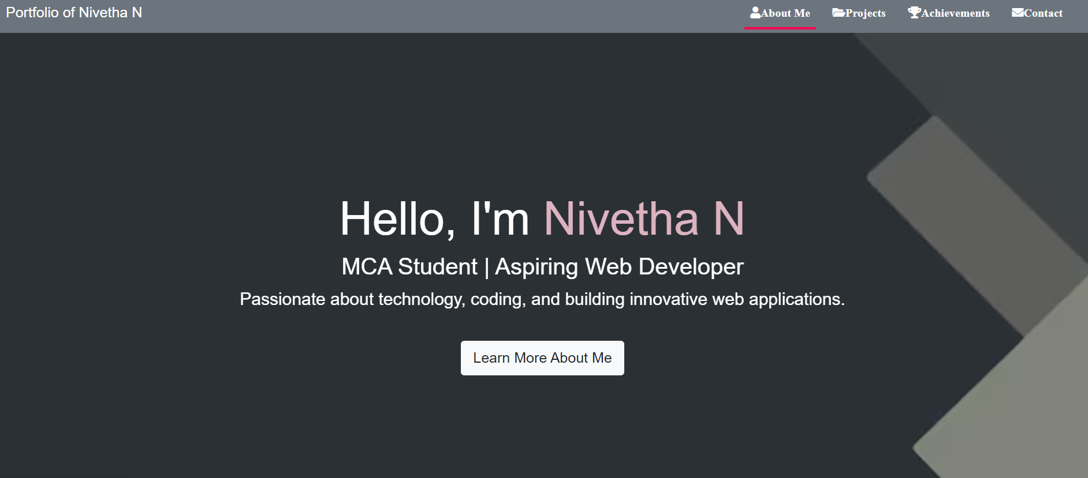

**ABOUT ME**

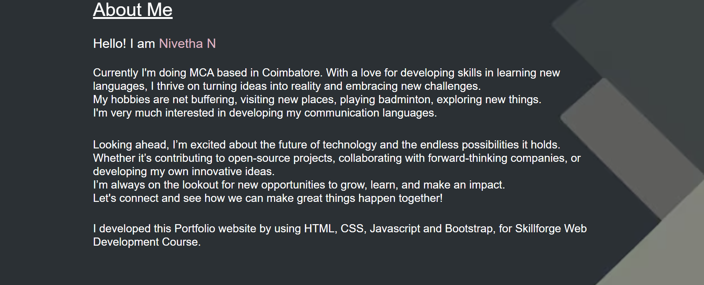

**PROJECTS**

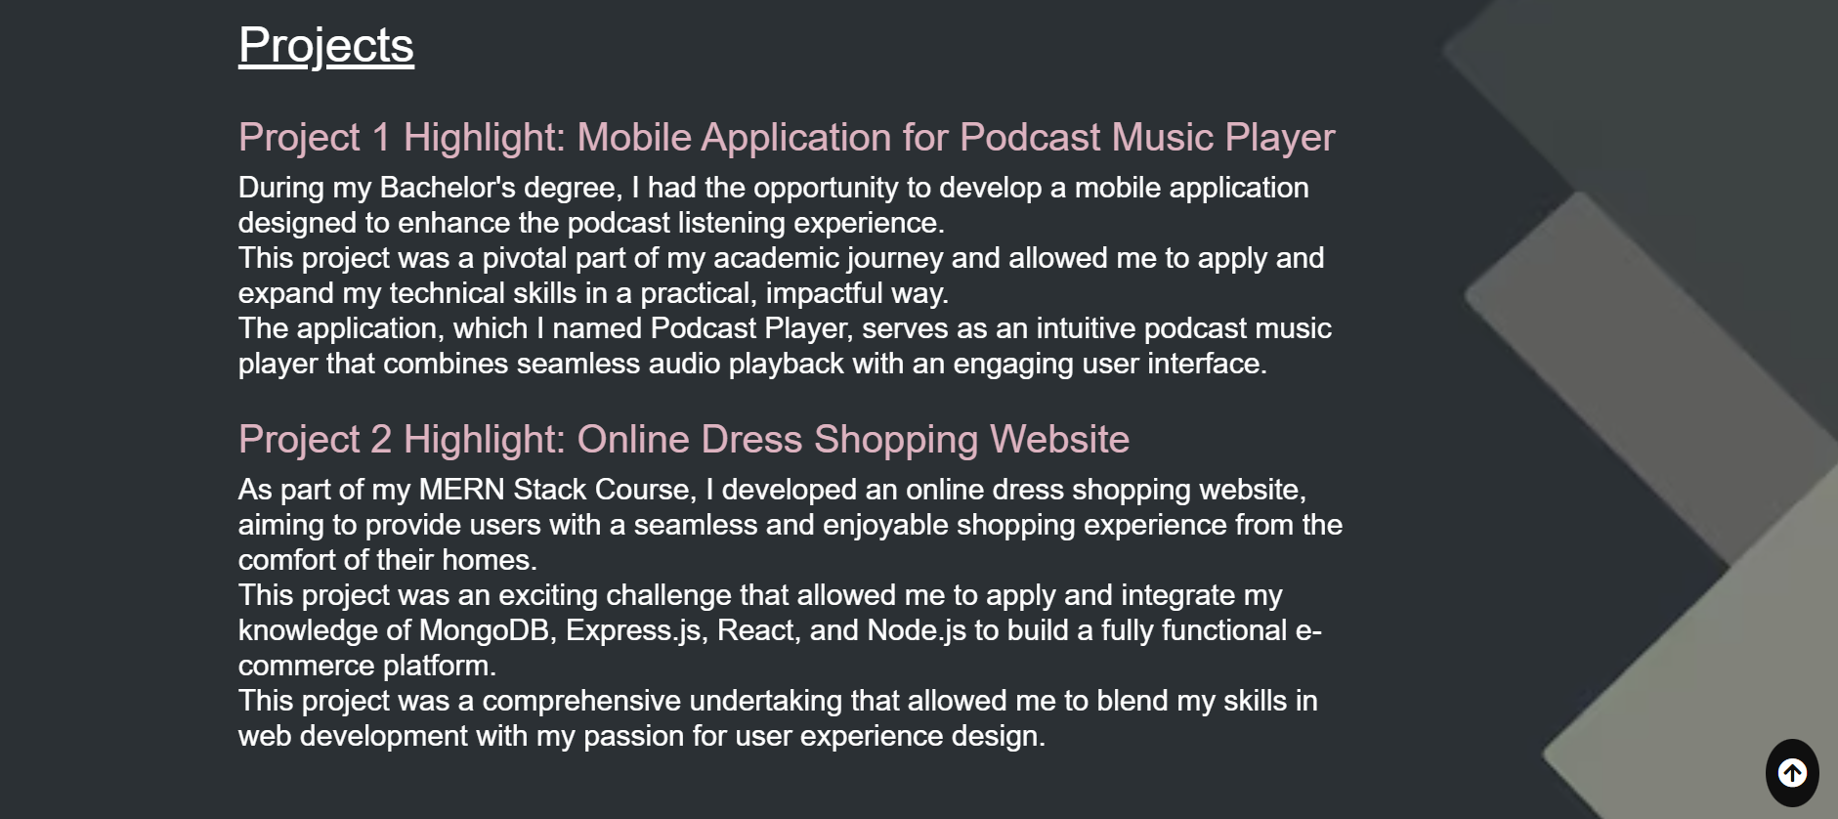

**ACHIEVEMENTS**

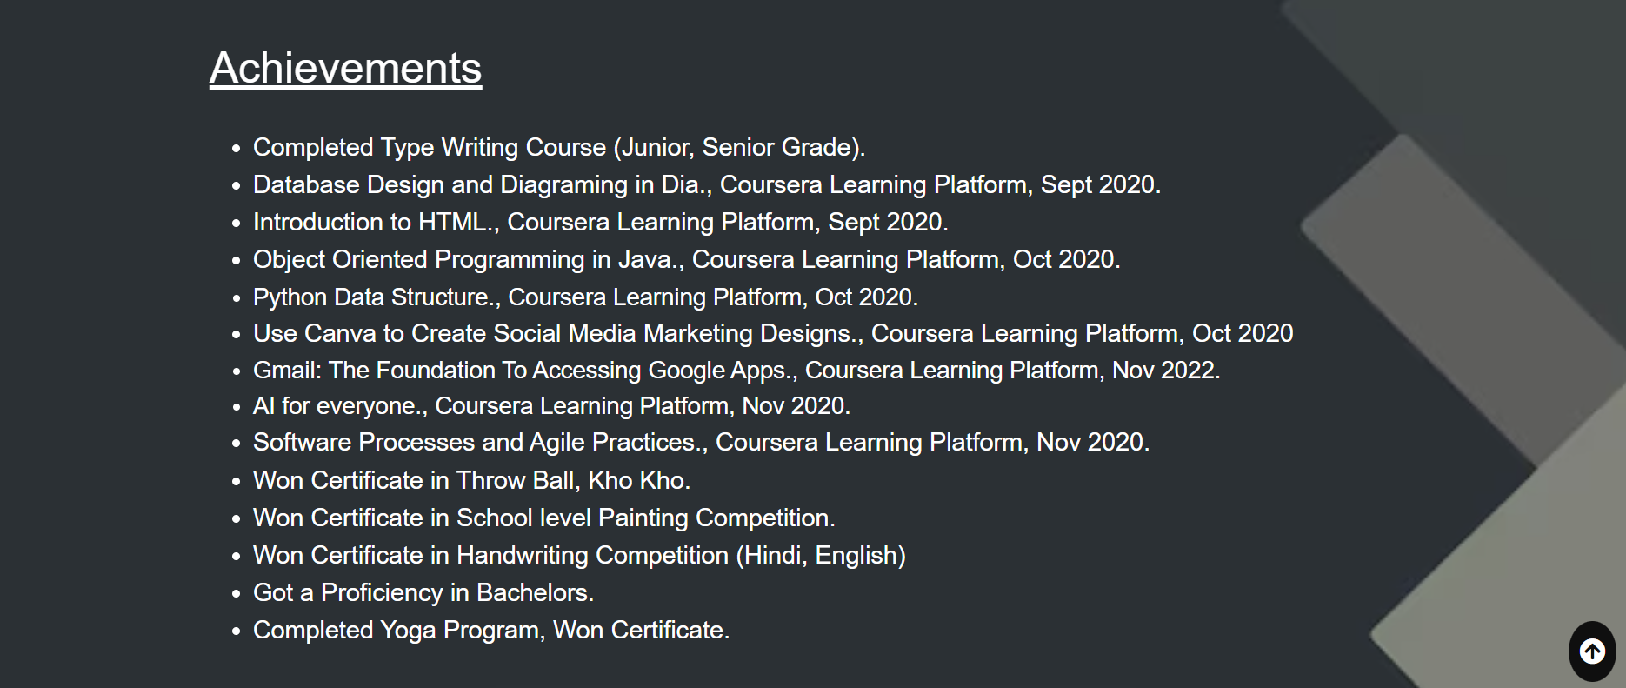

**CONTACT**

